***CURRICULUM VITAE***

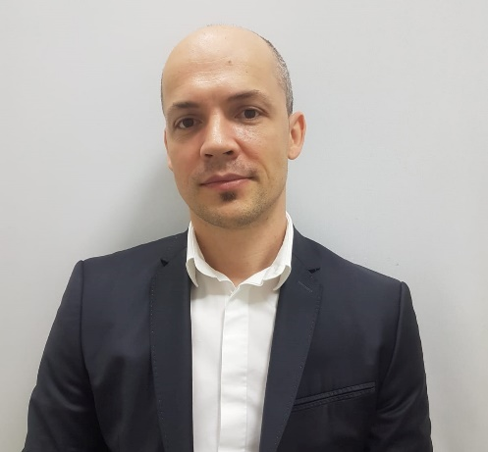

**Stoean Mihail**

Calea Victoriei 153

Bukarest, Romania

**Email:** [miksvens@yahoo.com](mailto:miksvens@yahoo.com)

**Tel:** 0040.772.171.136

**Driving licence cat B**

**"I can easily adapt to any kind of hospitality bussiness, I'm polyvalent, organized, discreet, bilingual and experienced working in this powerful medium and high-end industry."**

**Experience :**

1. **Restaurant Manager**

**June 2014 - Present**

**Restaurant Waterloo - Bucharest**

• A Belgian restaurant that offers good food and a very nice atmosphere in Bucharest

• Continuous improvement of the work environment and customer reception.

• Permanent transmission of information even during rush hours or last-minute changes.

• Event planning.

• Individual internal recognition and team motivation.

• Maximize profit by optimizing purchases.

**2. Waiter & Chef de Salle & Manager**

**Feb 2008 - June 2014**

**J Pizza Restaurant, Buzau**

• One of the best restaurants in Eastern Romania

• Exceptional service through timely and friendly customer service.

• All food and alcoholic drinks were served immediately.

• Answered questions about menu selection and made recommendations upon request.

• Regular guest reviews to ensure satisfaction with each meal and beverage.

**3. Assistent & Cook June**

**1998 - Feb 2008**

**Casa Doina, Bucharest**

• Cook and prepare a variety of fresh, nutritious lunch dishes and other refreshments.

• Supervising Food Service assistants and kitchen staff, organizing their daily tasks and monitoring performance.

• Ensure that adequate hygiene and cleanliness in the kitchen is maintained.

• Washing, cutting and preparing food before cooking.

• Consideration of customer requirements when planning menus.

• Ensure that good nutritional standards are observed when preparing meals.

**Education**

**1993 - 1997** High School “I.L. Caragiale”

**2011** Cook - Diploma

**Foreign languages**

English - advanced

German - medium

French - medium

**UPDATED: Jan 2019**